i

Module 3 Lab 3

Advanced Routing Protocols Lab- Setup

ITSC 206: Advanced Networking for Offensive and Defensive Environments

Table of Contents

Lab Setup 2

Files/Download 2

Reading 2

Introduction 2

Initial Switch/Router Setup 2

Kali VM Loki Setup 3

Configure BGP Setup 5

Configure OSPF Setup 5

Lab Setup

* Review architecture for each configuration and optimize.

Resource/Files/Download

* Layer 2 or 3 Switch (Cisco Catalyst 2950 or 3750)
* Virtual Machines
  + Attacker Loki – Win10 (VM or Virtualbox)
  + Victim - Win2k12R2
  + Victim - Win10 or 7 or Kali

Reading

* None

Introduction

This document supports the setup of Lab3.

Initial Switch/Router Setup

This lab gives you practice in the securing of BGP and in the basic configuration and troubleshooting of a physical install.

1. Addressing Table

|  |  |  |  |
| --- | --- | --- | --- |
| Device | Interface | IP Address | Subnet Mask |
| SwitchA | VLAN 1 | 172.16.0.1 | 255.255.255.0 |
| RouterA | Fa0/0 | 10.100.200.1 | 255.0.0.0 |
| RouterA | Fa0/1 | 172.16.0.254 | 255.255.255.0 |
| SwitchB | VLAN 1 | 172.16.4.1 | 255.255.255.0 |
| RouterB | Fa0/0 | 10.200.200.1 | 255.0.0.0 |
| RouterB | Fa0/1 | 172.16.4.254 | 255.255.255.0 |
| Attacker | NIC | 172.16.0.4 | 255.255.255.0 |
| Laptop | NIC | 172.16.0.2 | 255.255.255.0 |
| Server | NIC | 172.16.4.2 | 255.255.255.0 |



RouterA should be configured to have 3 addresses:

• FE0 should have an address in the 10/8 range – 10.100.200.1/8

• FE1 should have an address in the 172.16.0.0/22 range – 172.16.3.254/22

• Loopback address – 172.16.3.1/32

SwitchA

• VLAN1 – 172.16.0.1/22

RouterB should be configured to have 3 addresses:

• FE0 should have an address in the 10/8 range – 10.200.200.1/8

• FE1 should have an address in the 172.16.4/22 range – 172.16.4.254/22

• Loopback address – 172.16.7.1/32

SwitchB

• VLAN1 – 17.16.4.1/22

1.0 Configuring Switches, Routers and BGP

1. Connect via serial into RouterA and give it the addresses stipulated above :

Router#conf t

Router(Config)#hostname RouterA

RouterA(Config)# interface Fastethernet0/0

RouterA(Config-if)#ip address 10.100.200.1 255.0.0.0

RouterA(Config-if)#interface Fastethernet0/1

RouterA(Config-if)#ip address 172.16.0.254 255.255.255.0

RouterA(Config-if)#interface loopback0

RouterA(Config-if)#ip address 172.16.3.1 255.255.255.255

RouterA(Config-if)#exit

RouterA(Config)#end

2. Connect via serial into SwitchA and give it the addresses stipulated above :

Switch#conf t

SwitchA(Config)#hostname SwitchA

SwitchA(Config)#interface vlan1

SwitchA(Config-if)#ip address 172.16.0.1 255.255.255.0

SwitchA(Config-if)#exit

SwitchA(Config)#ip default-gateway 172.16.0.254

SwitchA(Config)#end

3. Connect via serial into RouterB and give it the addresses stipulated above :

Router#conf t

Router(Config)#hostname RouterB

RouterB(Config)#interface Fastethernet0/0

RouterB(Config-if)#ip address 10.200.200.1 255.0.0.0

RouterB(Config-if)#interface Fastethernet0/1

RouterB(Config-if)#ip address 172.16.4.254 255.255.252.0

RouterB(Config-if)loopback0

RouterB(Config-if)#ip address 172.16.7.1 255.255.255.255

RouterB(Config-if)#exit

RouterB(Config)#end

4. Connect via serial into SwitchB and give it the addresses stipulated above :

Switch#conf t

Switch(Config)#hostname SwitchB

SwitchB(Config)#interface vlan1

SwitchB(Config-if)#ip address 172.16.4.1 255.255.252.0

SwitchB(Config-if)#exit

SwitchB(Config)#ip default-gateway 172.16.4.254

SwitchB(Config)#end

Kali VM Loki Setup

Setup Kali with the following attributes in the VM Player:

1. Download/load Windows 10 VM or Virtualbox image onto workstation or laptop
2. Change Win10 to Bridged NIC of wired network connection

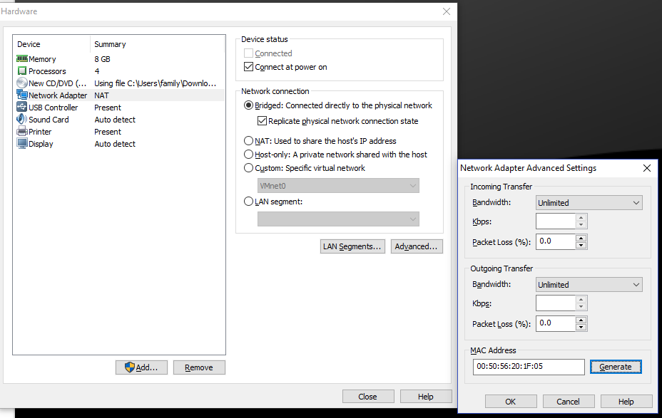

1. Start up Win10 VM or Virtualbox
2. Connect on A side and change the IP address to a static address of 172.16.0.4/22
3. Download Loki package Loki-0.2.7.zip from D2L Student Resources and extract
4. Install Loki on Win10 (VM or Virtualbox) Loki-0.2.7.exe

Configure BGP Setup

1. Let’s configure BGP routing on each router to exchange routes

On RouterA, issue the following command:

RouterA#conf t

RouterA(config-router)#router bgp 64001

RouterA(config-router)# bgp log-neighbor-changes

RouterA(config-router)# bgp maxas-limit 50

RouterA(config-router)# aggregate-address 172.16.0.0 255.255.252.0 summary-only

RouterA(config-router)# redistribute connected

RouterA(config-router)# redistribute static

RouterA(config-router)# neighbor 10.200.200.1 remote-as 65001

RouterA(config-router)# neighbor 10.200.200.1 soft-reconfiguration inbound

RouterA(config-router)#end

On RouterB, issue the following command:

RouterB#conf t

RouterB(config-router)#router bgp 65001

RouterB(config-router)# bgp log-neighbor-changes

RouterB(config-router)# bgp maxas-limit 50

RouterB(config-router)# aggregate-address 172.16.3.0 255.255.252.0 summary-only

RouterB(config-router)# redistribute connected

RouterB(config-router)# redistribute static

RouterB(config-router)# neighbor 10.100.200.1 remote-as 64001

RouterB(config-router)# neighbor 10.100.200.1 soft-reconfiguration inbound

RouterB(config-router)#end

1. If you issue the command *sh ip route* on RouterA, you should see in your routing table
   1. 172.16.4.0/22
2. Confirm network connectivity by ping from Attacker w/ Loki to SwitchB (172.16.4.254)

Configure OSPF Setup

1. Let’s configure OSPF routing on each router to exchange routes

On RouterA, issue the following command :

RouterA#conf t

RouterA(config-router)#router ospf 10

RouterA(config-router)#router-id 172.16.3.1

RouterA(config-router)#auto-cost reference-bandwidth 10000

RouterA(config-router)#redistribute connected subnets

RouterA(config-router)#no passive-interface Fastethernet 0/0

RouterA(config-router)#network 172.16.0.0 0.0.3.255 area 0

RouterA(config-router)#int Fa 0/0

RouterA(config-if)#ip ospf network point-to-point

RouterA(config-if)#end

On RouterB, issue the following command :

RouterB#conf t

RouterB(config-router)#router ospf 10

RouterB(config-router)#router-id 172.16.7.1

RouterB(config-router)#auto-cost reference-bandwidth 10000

RouterB(config-router)#redistribute connected subnets

RouterB(config-router)#no passive-interface Fastethernet 0/0

RouterB(config-router)#network 172.16.4.0 0.0.3.255 area 0

RouterB(config-router)#int Fa 0/0

RouterB(config-if)#ip ospf network point-to-point

RouterB(config-if)#end

1. If you issue the command *sh ip route* on RouterA, you should see in your routing table
   1. 172.16.4.0/22
2. Confirm network connectivity by ping from Attacker w/ Loki to SwitchB (172.16.4.254)

Blank page if necessary to make pages an even number

**DO NOT DELETE THE SECTION BREAK BELOW. DELETING IT MAY IMPACT THE FORMATTING IN THIS DOCUMENT.**